ROBOTITO

One robot was designed and built. Battery life was not tested because the robot has been run on DC from an adapter. There will be two lithium batteries used for mobile use of the robot, when the batteries arrive, battery life will be tested.

The files used for the tests were in the Software folder.

-camera.py tests the functionality of the camera.

-encoder.py tests the functionality of the encoders

-motorDriver.py tests the motors

-sensors.py tests the IR sensors

-spidev test tests the MCP3008

Tests were done to verify functionality of the components after the build

**google & stackoverflow are your friends**

* 3D parts were designed in Blender to fit 8 sensors, 4 motors and encoders, a camera, a Raspberry Pi 3, and Adafruit Motor Shield, yet still maintain as much of the original Robotito design as possible.

* Blender files use .blend format. Those were then exported to .stl files to 3D print them.

* Files to 3D print for the Robotito are found in the RobotitoParts folder

Camera Back x 1

Camera Front x 1

Miniwheels x 64

WheelTotal(This file contains 2 wheels) x 2

SensorHolderTotal x 1

RobotitoChassis x 1

* Parts to order are in \robotito-master\V2\PartsToOrder.xls

* The motors chosen were 6v with 1.2 stall amps. They have a gearbox reducing the RPM to ~500RPM. This should provide plenty of torque to accelerate the robot, and plenty of speed to move the robot quickly. The motors have hall sensor encoders to give precise feedback of the rotation of each wheel to aid in positioning.

***********************************ROBOTITO BUILD***********************************

WIRING

(**FIRST** Test all components via breadboard to ensure they work properly)

* Solder provided female headers(To connect to the pi) to BOTTOM of Adafruit Motor Driver Servo Hat(AMD)

* Solder motor wire mounts to the TOP of the AMD

* Solder 13 pin male headers to TOP of AMD in GND, 3V, and 5V

* Solder male header pins to TOP of AMD for additional Pi inputs (at least for CE0, MOSI, MISO, and SCLK)

* Place 16 pin socket on BOTTOM of board prototyping area, with 5 pads to the left and 6 pads to the right of it. Bend the pins inward so they are touching the pad directly above or below it.

* Solder MCP3008 socket pins as well as the pads next to them that they are bent towards to create connection points for the wires.

* Solder a group of header wires(the male end) to each pad next to a pin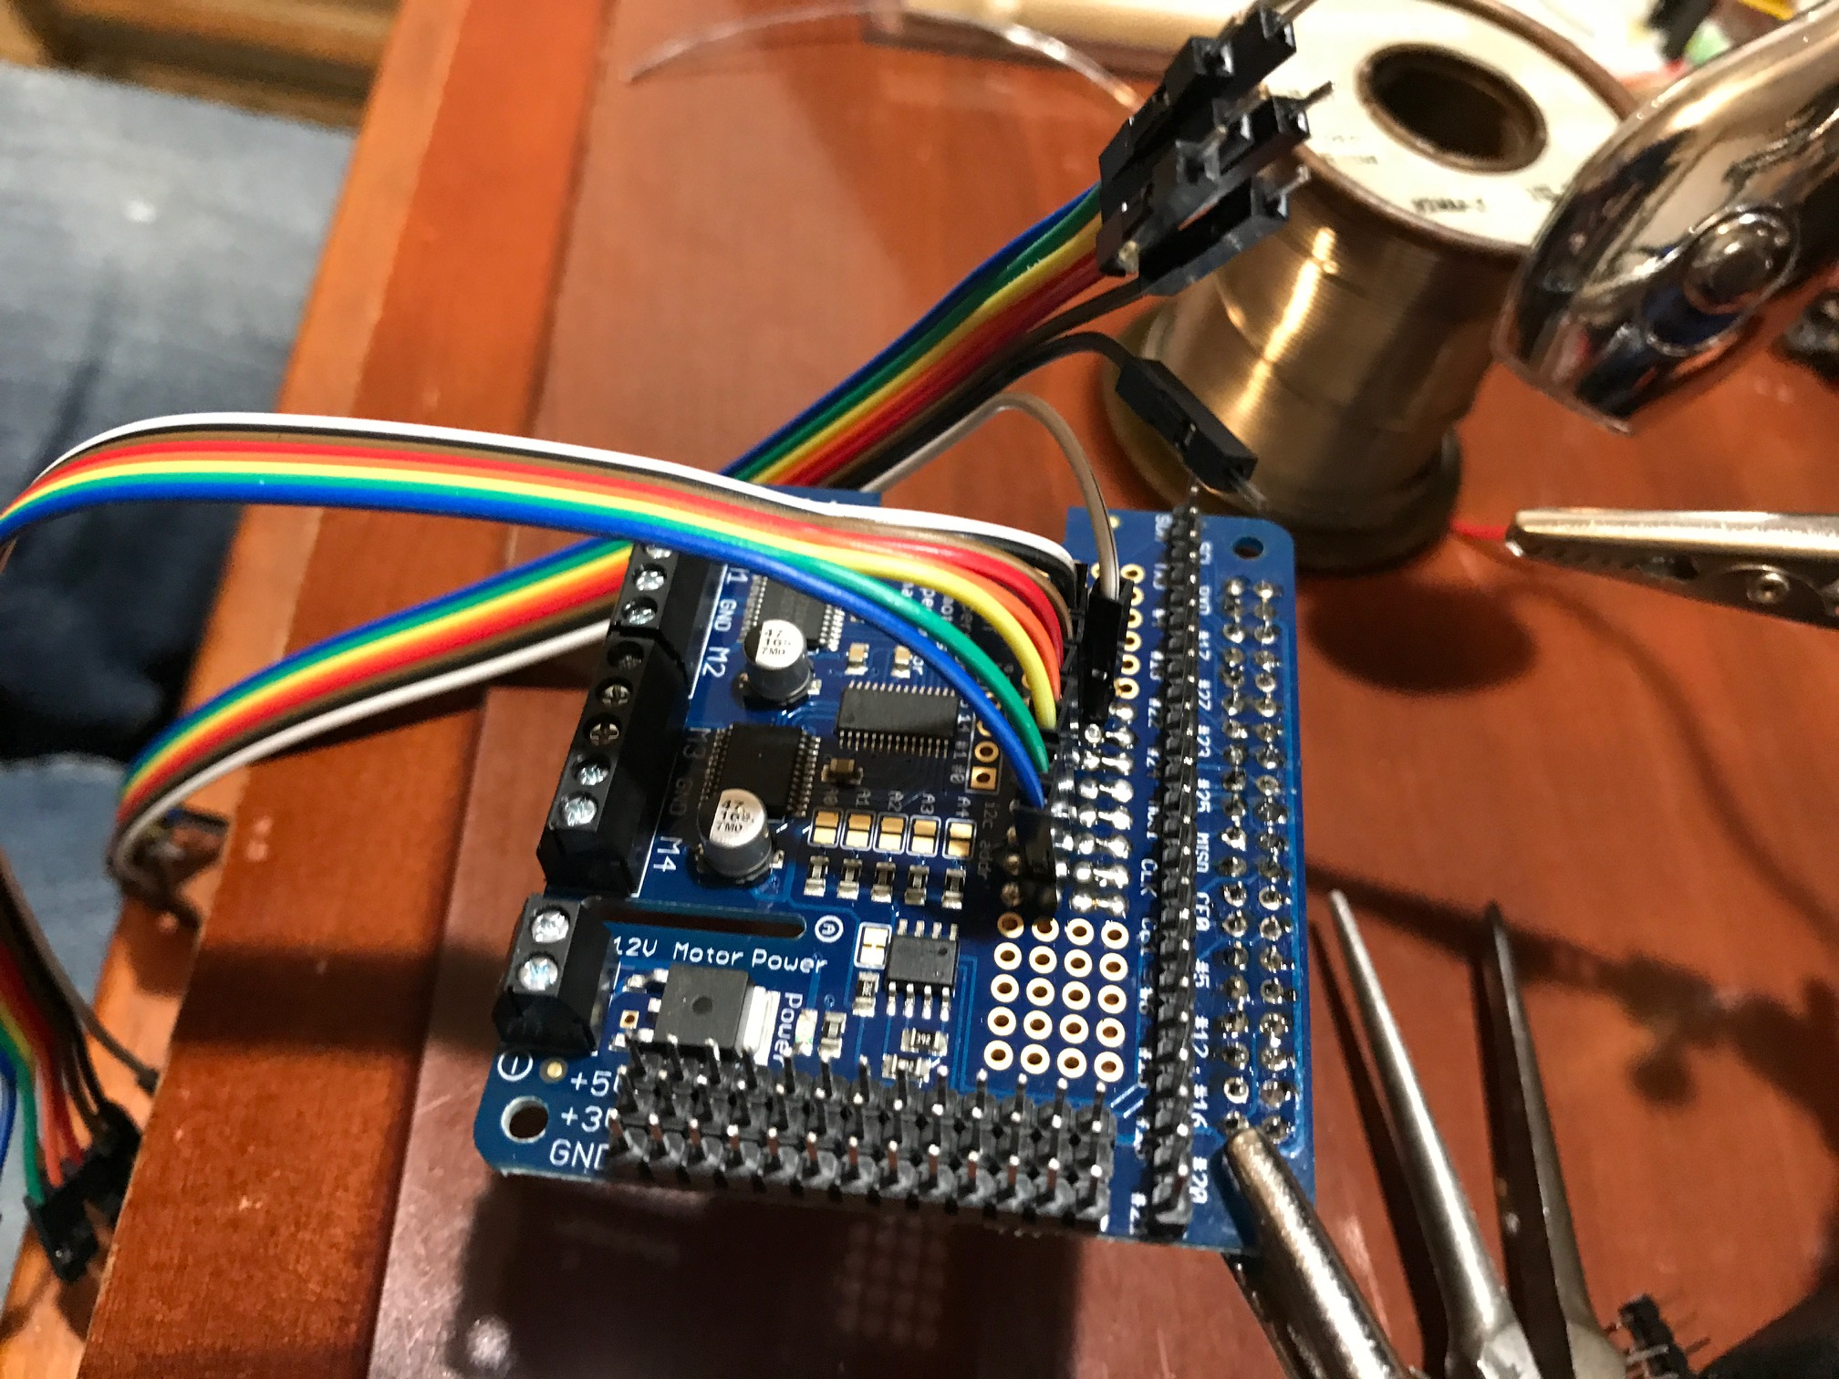

Header Wires

Second and third row of pads

Female header pins(Provided with AMD)

Motor Pins

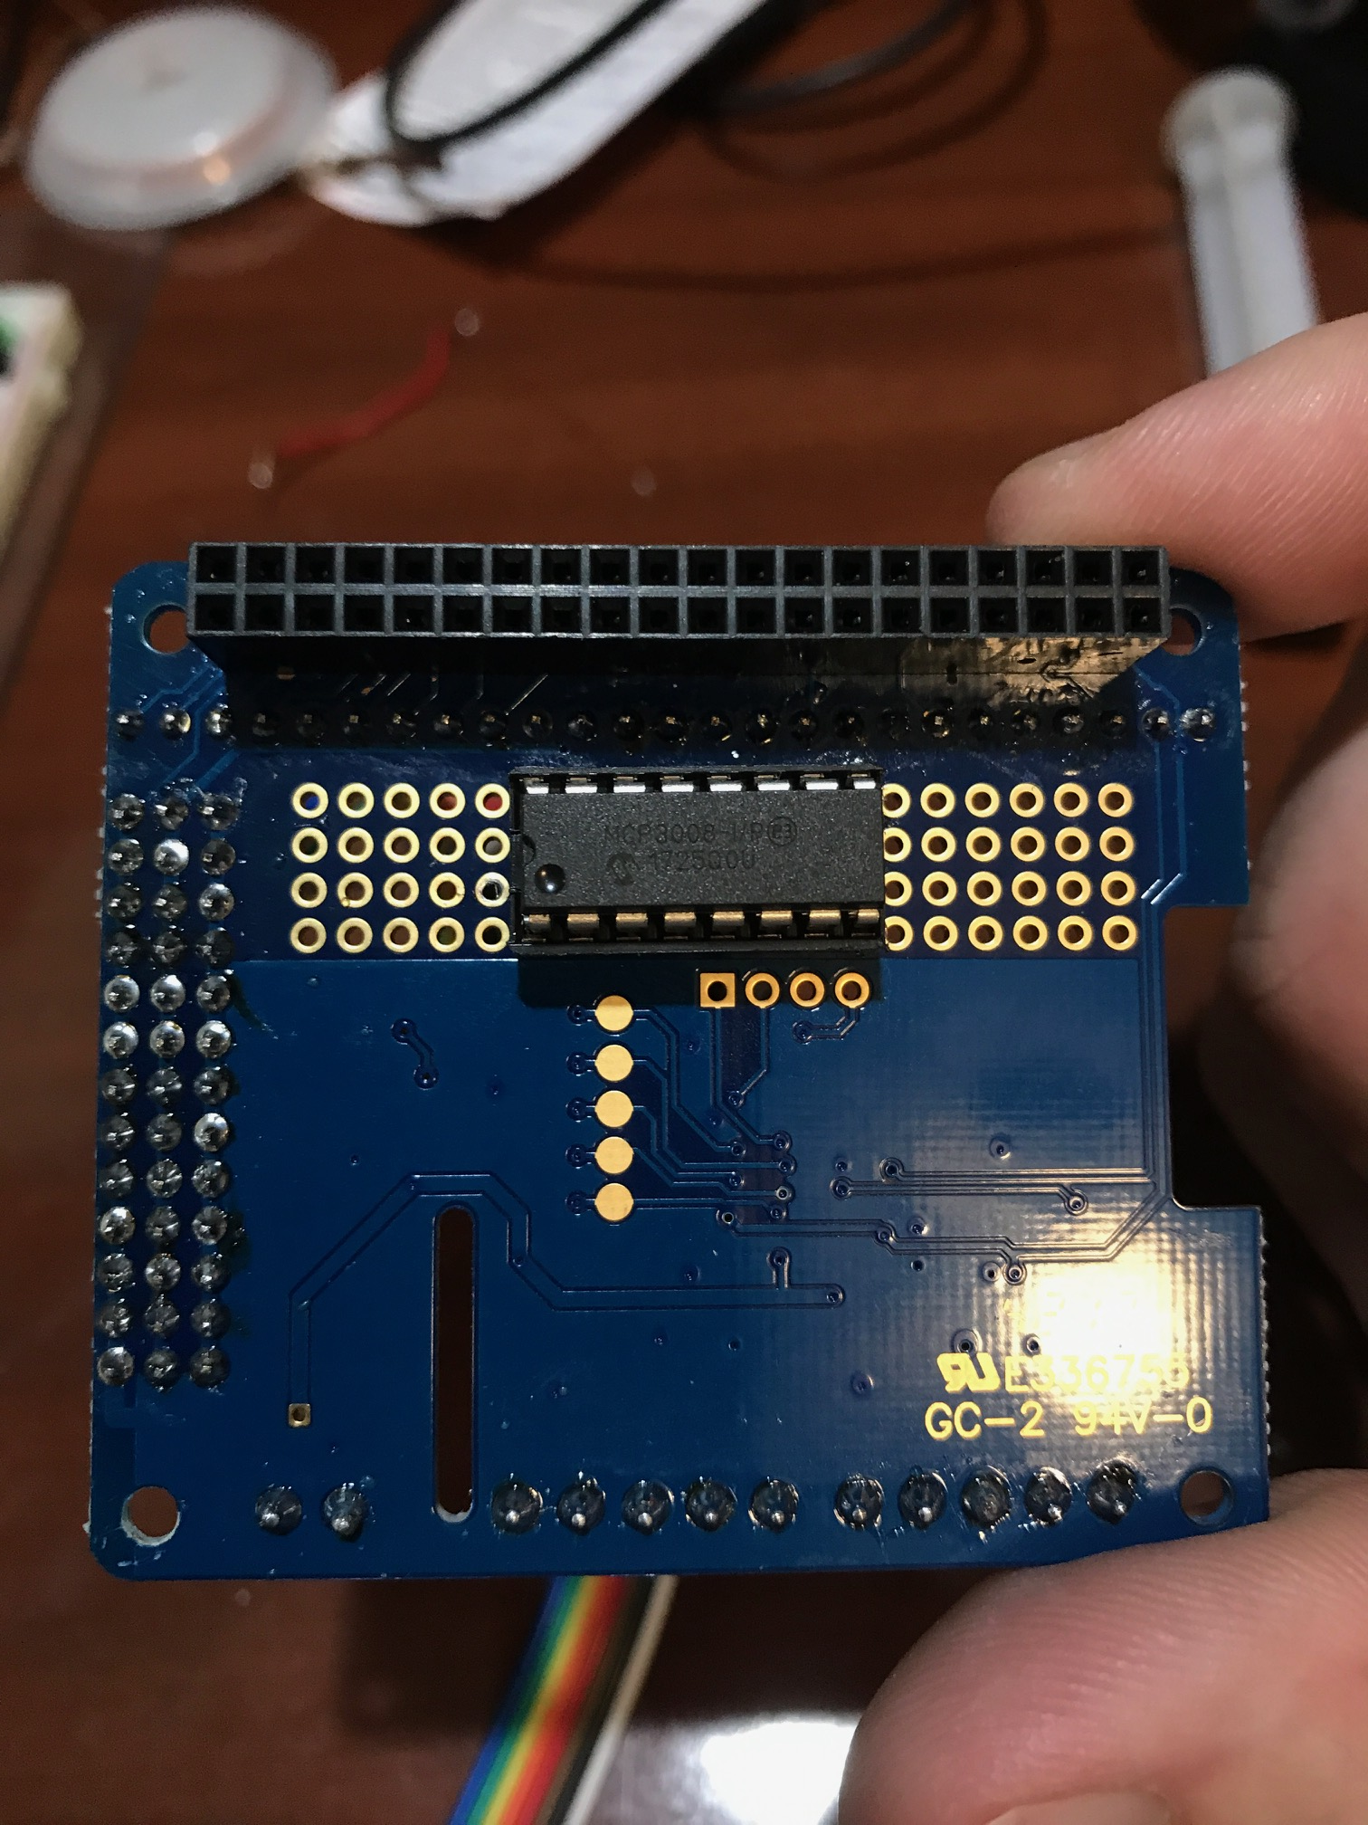The dotted side of the chip will be facing the camera when holding the board at this angle

Female header pins(Provided with AMD)

MCP3008 in 16 pin socket. (Top facing downwards)

Motor Connections

Three rows of 13 header pins. Vcc(5v), Vcc (3v), Gnd

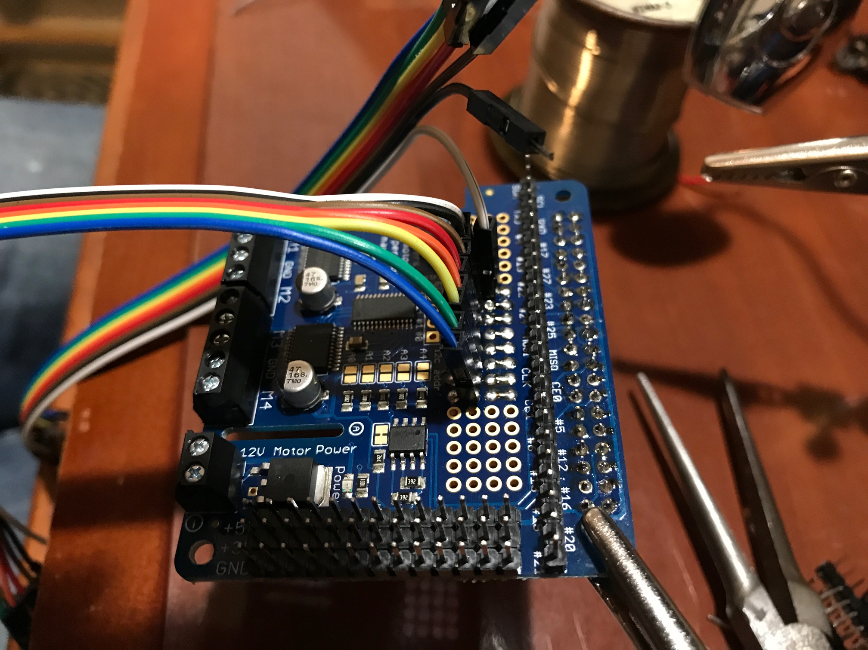 Pins from 16 pin socket bridged to appropriate header wire pin

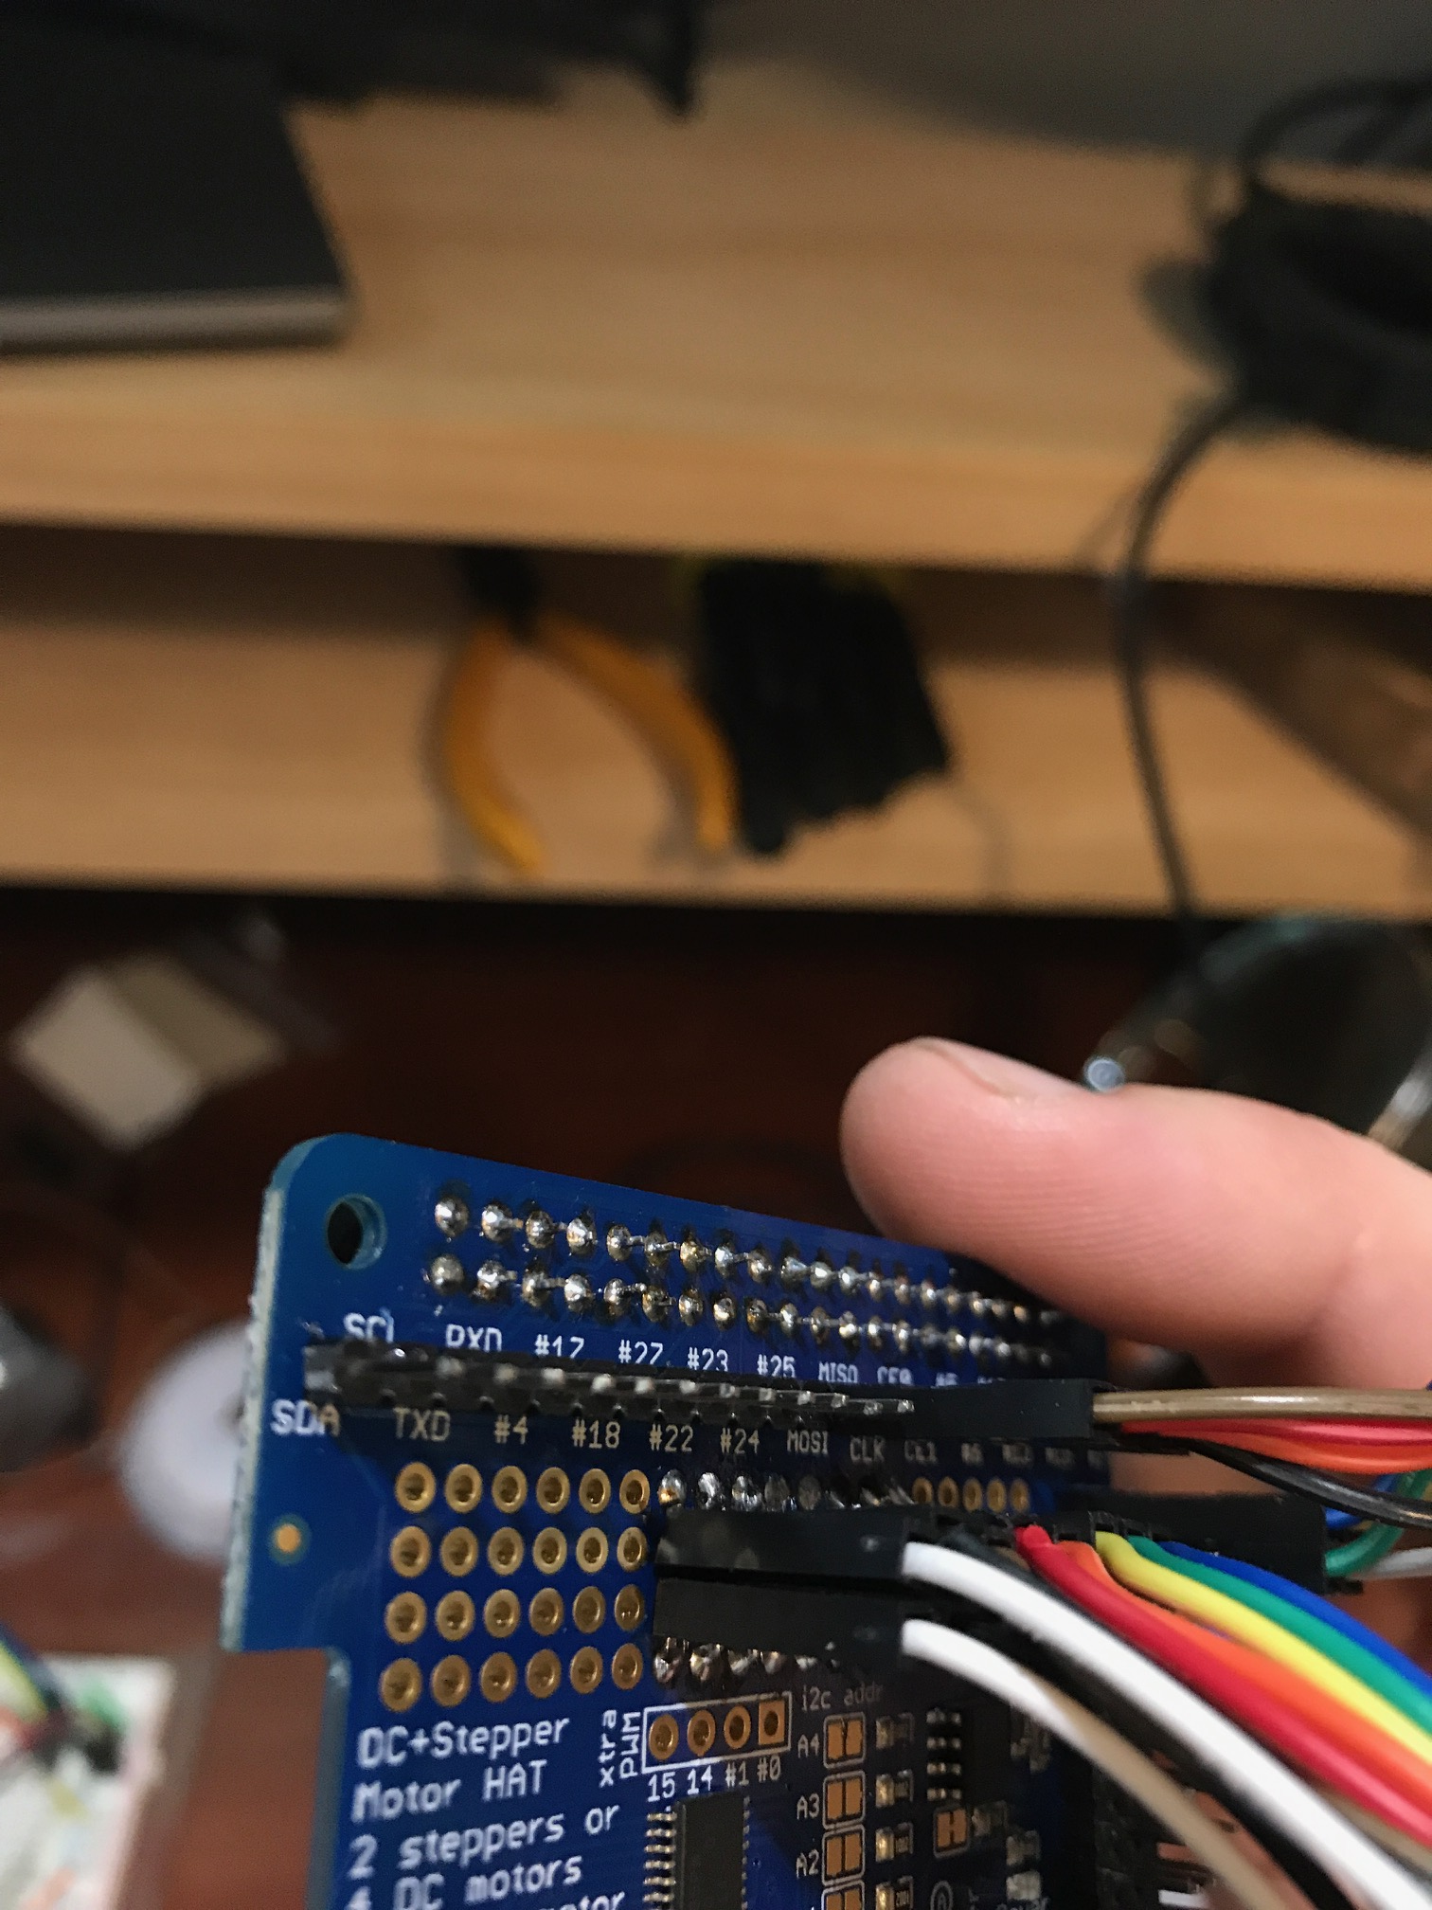

Pins from 16 pin socket bridged to appropriate header wire pin

* Test for continuity, and make sure there aren't any accidentally bridged solder pads

* Crimp a male pin to the Vcc on all sensors, and female pins on the remaining wires

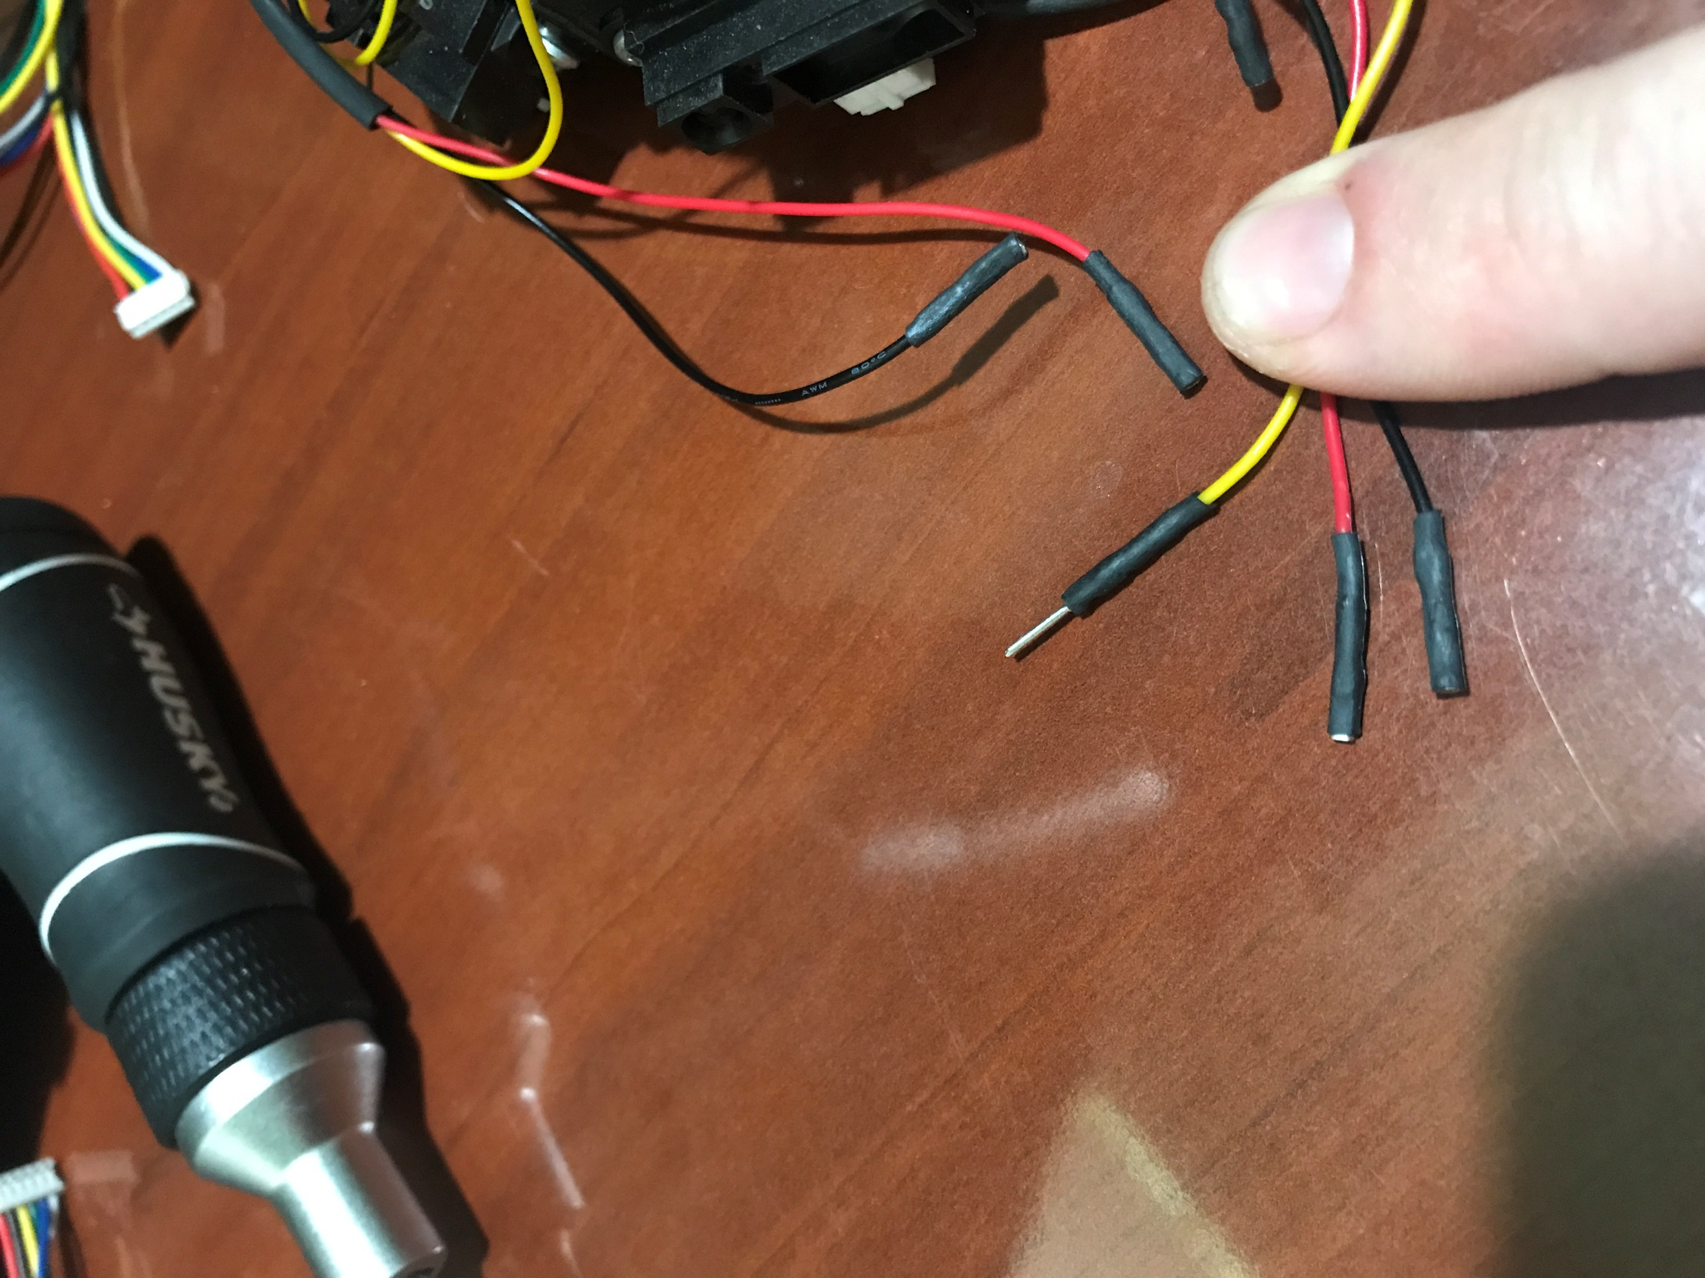

Wire from sensor signal (Male Dupont Connector and shrink tubing)

Wire from Vcc of sensor(Female Dupont Connector and shrink tubing)

Wire from Gnd of sensor(Female Dupont Connector and shrink tubing)

* Pass camera cable through the hole on the AMD and connect to Pi camera port

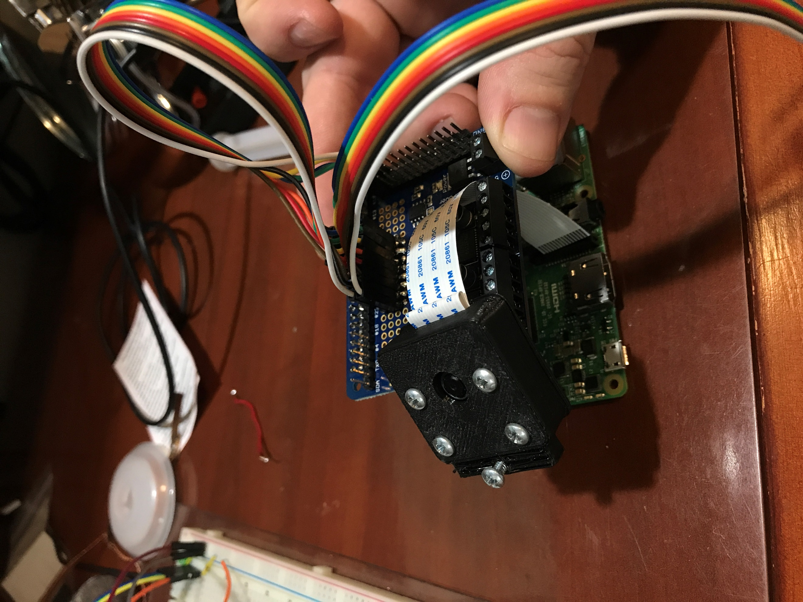

Camera cable(make sure to align the exposed parts of the cable to the right side of the connector on the pi)

Camera case

* Connect all the wires to the appropriate pins

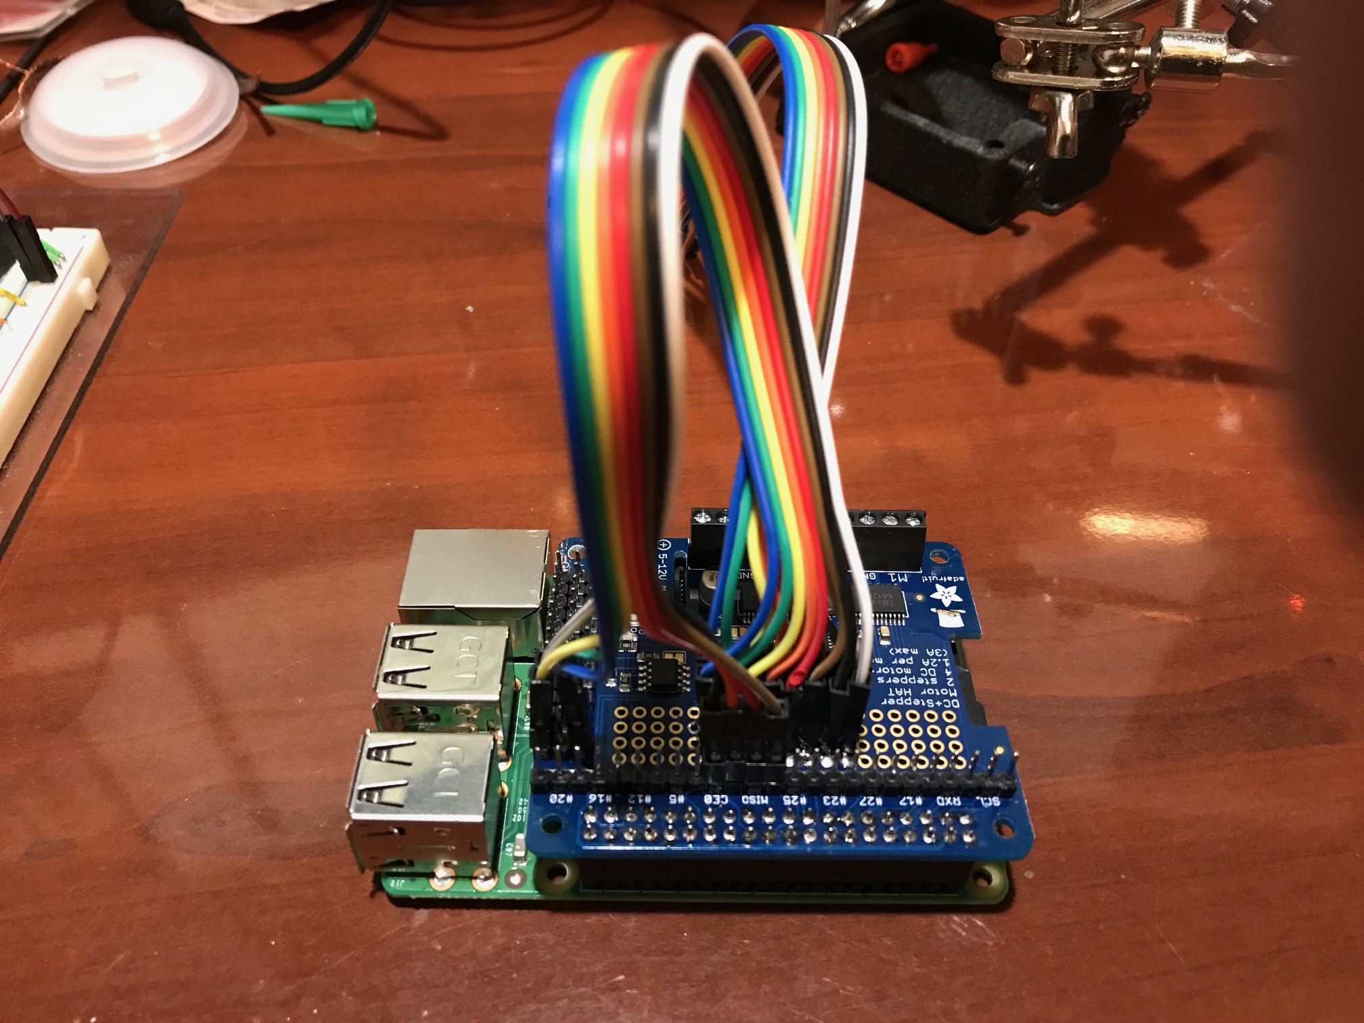

CHASSIS & WHEELS

* Attach hub to one side of wheel with two screws, across from each other

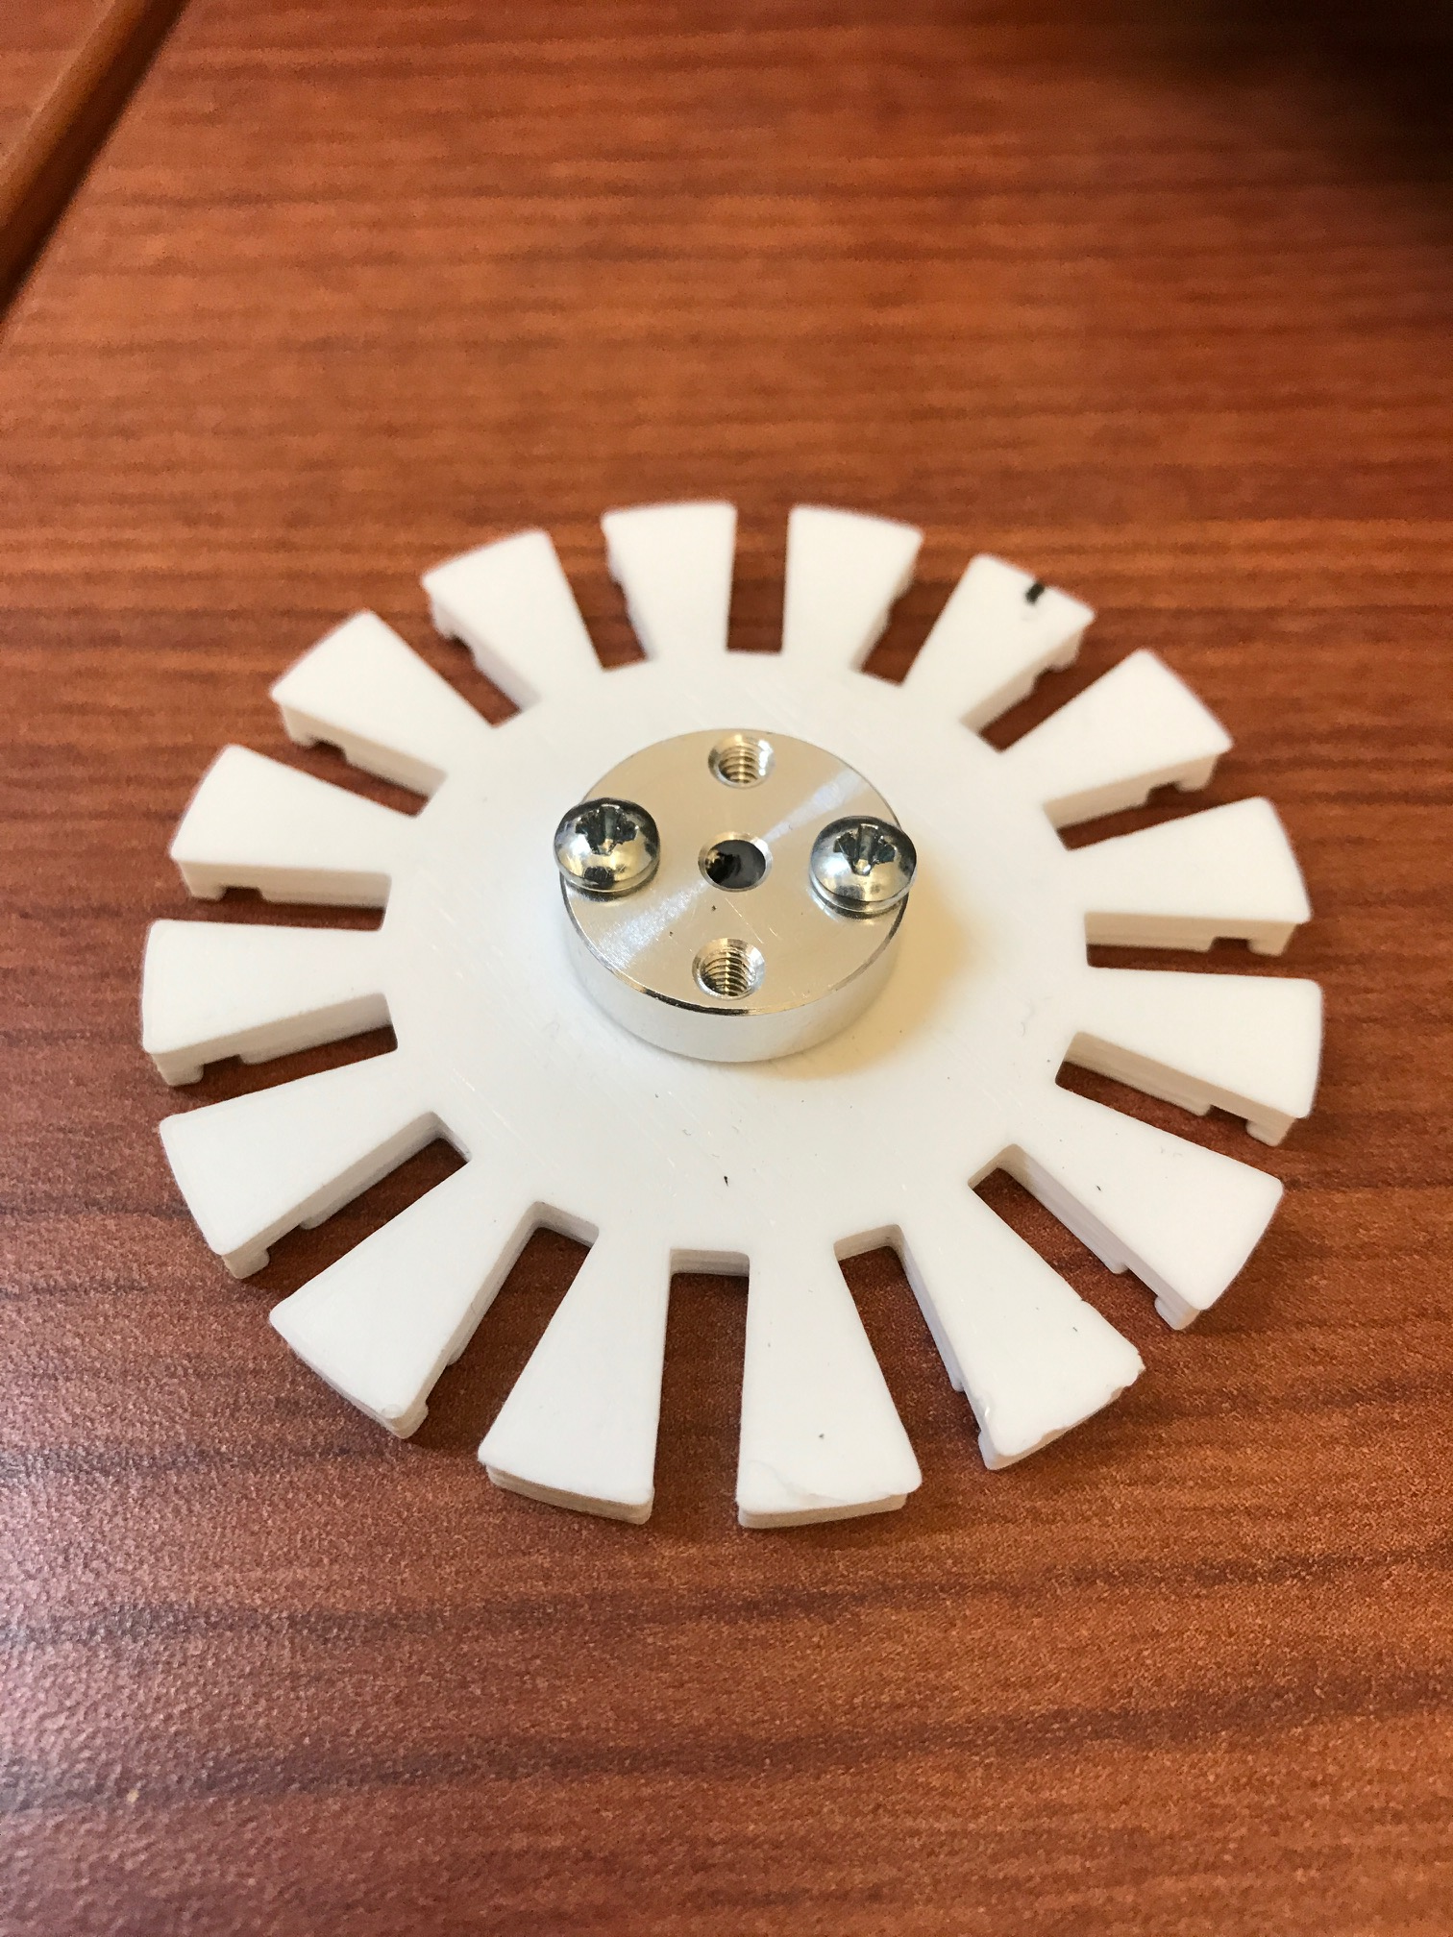 Hub

Wheel

* Insert axle into miniwheels and place in wheel back with hub

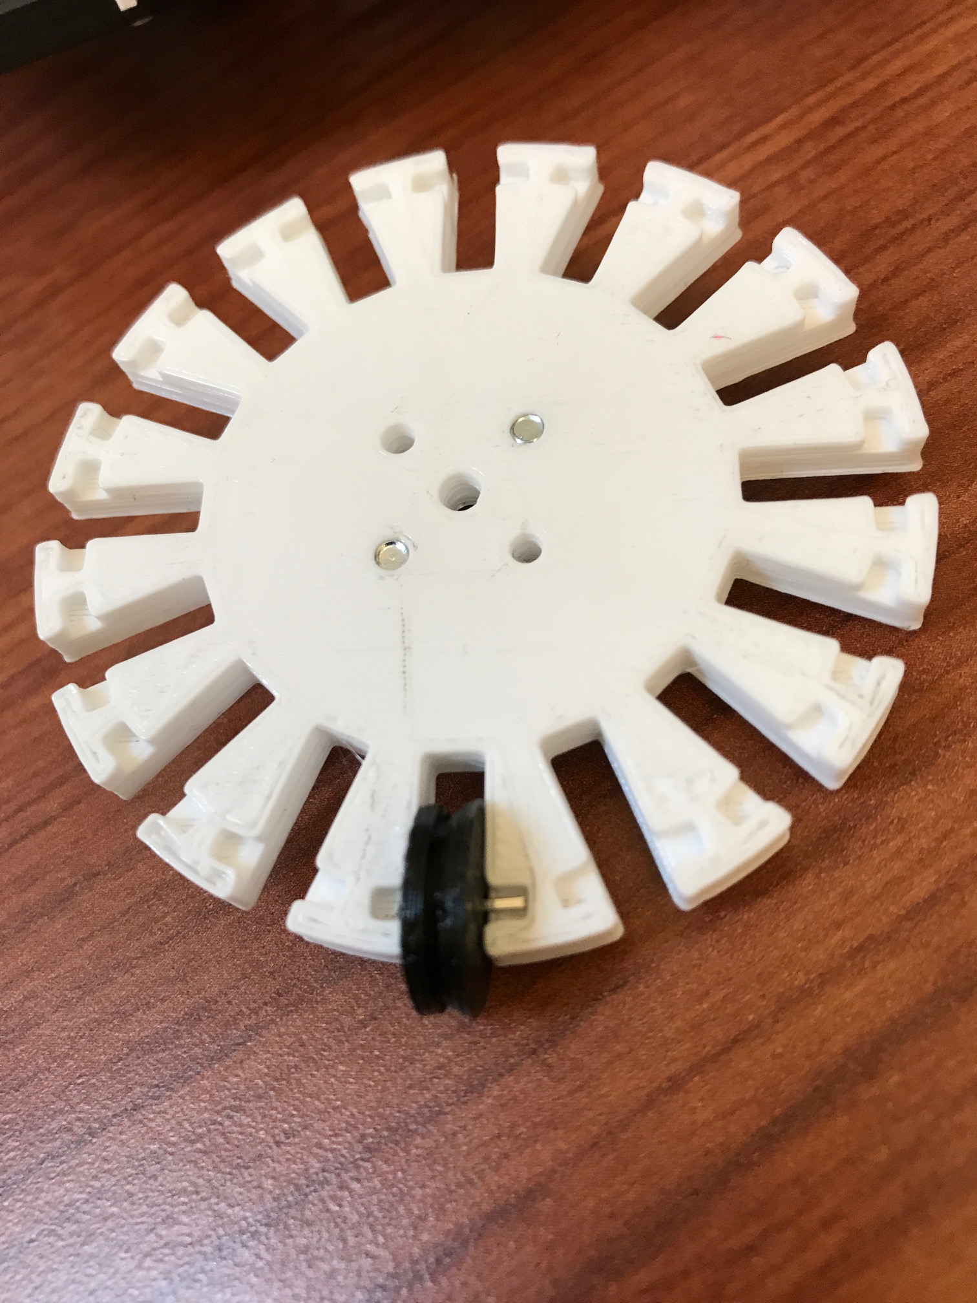 Miniwheel

Axle(Made from header pin)

* Attach front of wheel to back of wheel and hub. (Screw in two remaining open holes in wheel * Insert motors into motor bracket

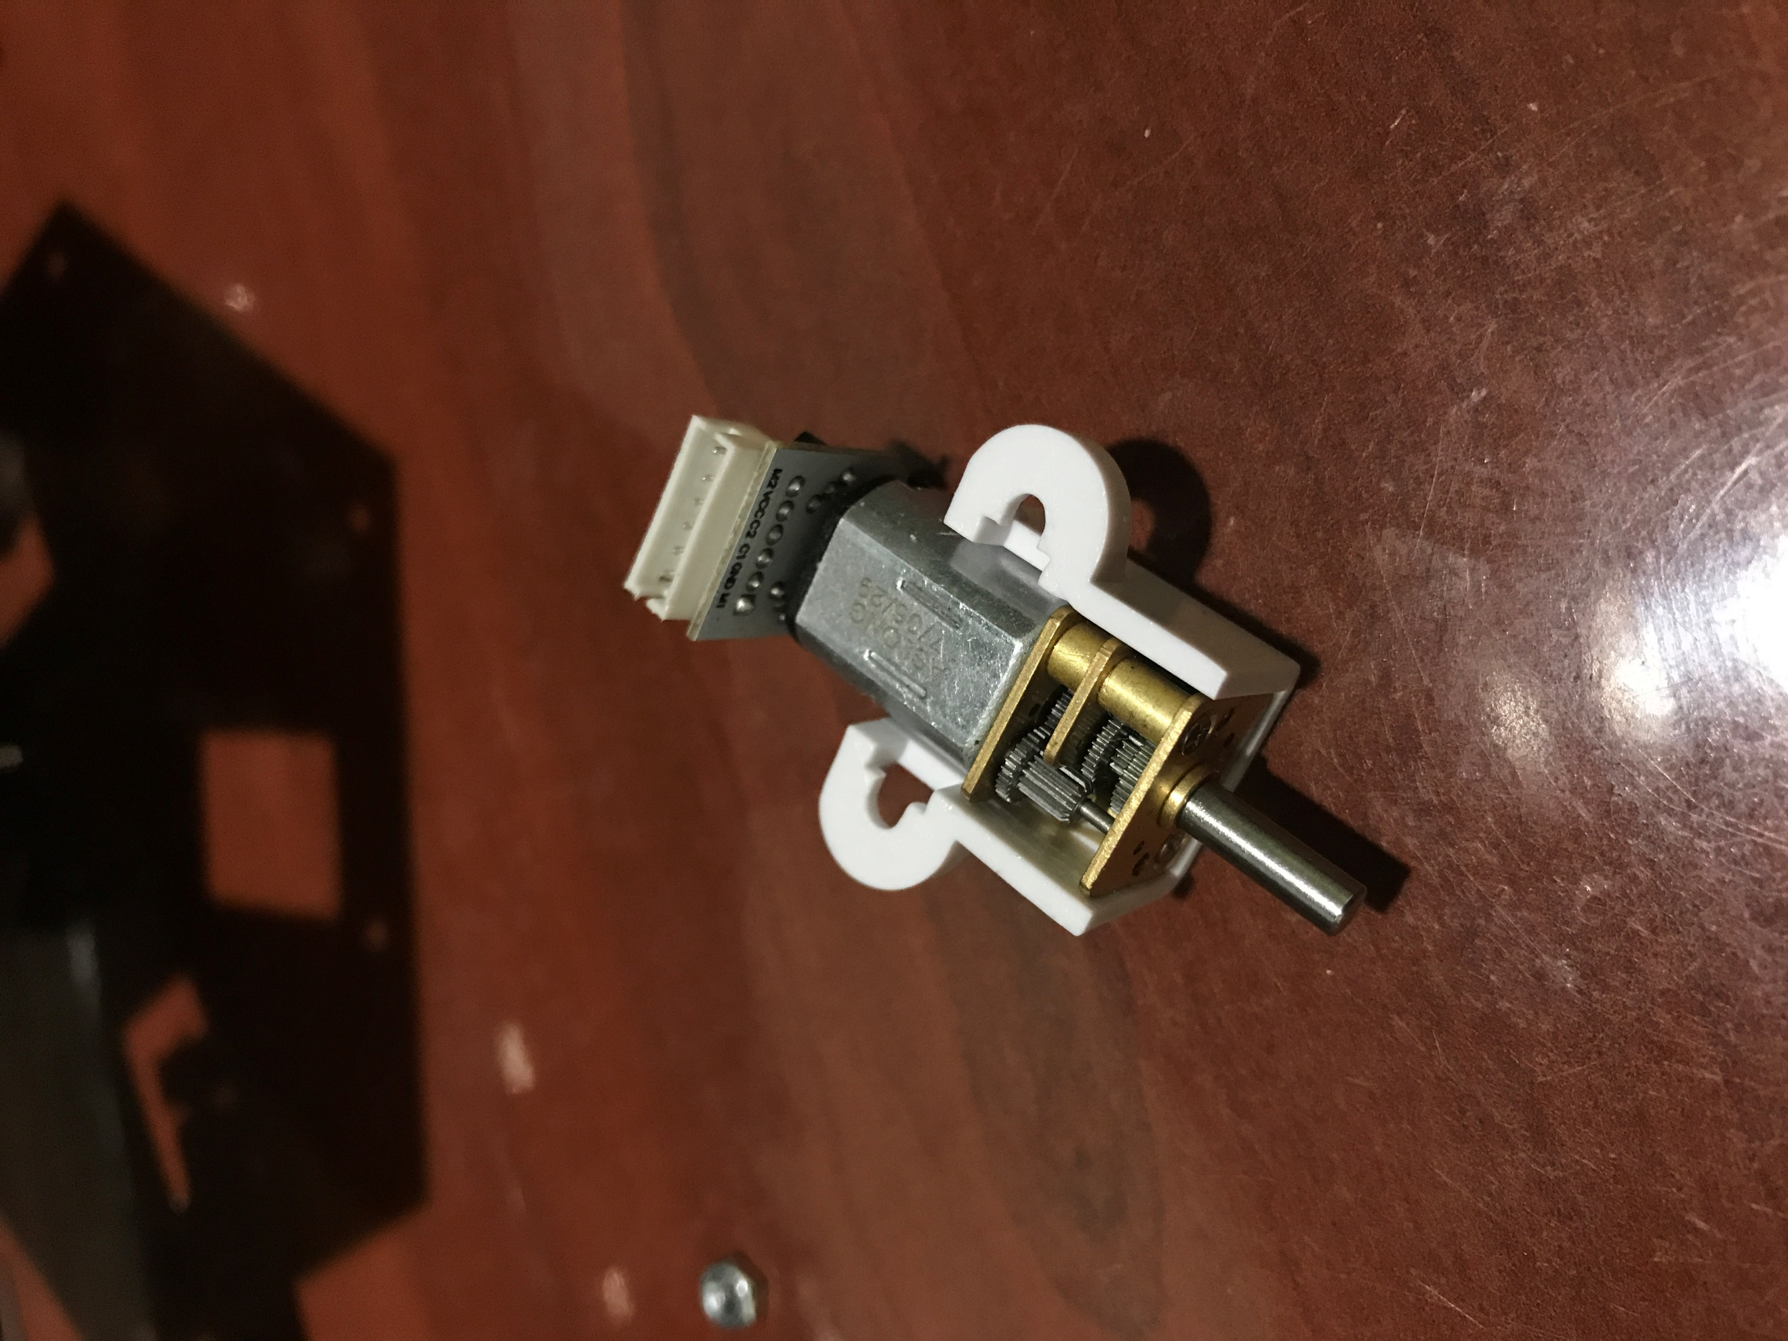

Motor Bracket

Motor(with attached encoder)

* Attach motors/brackets to chassis (Ensure the wires from the encoder are passing upwards through the holes in the chassis)

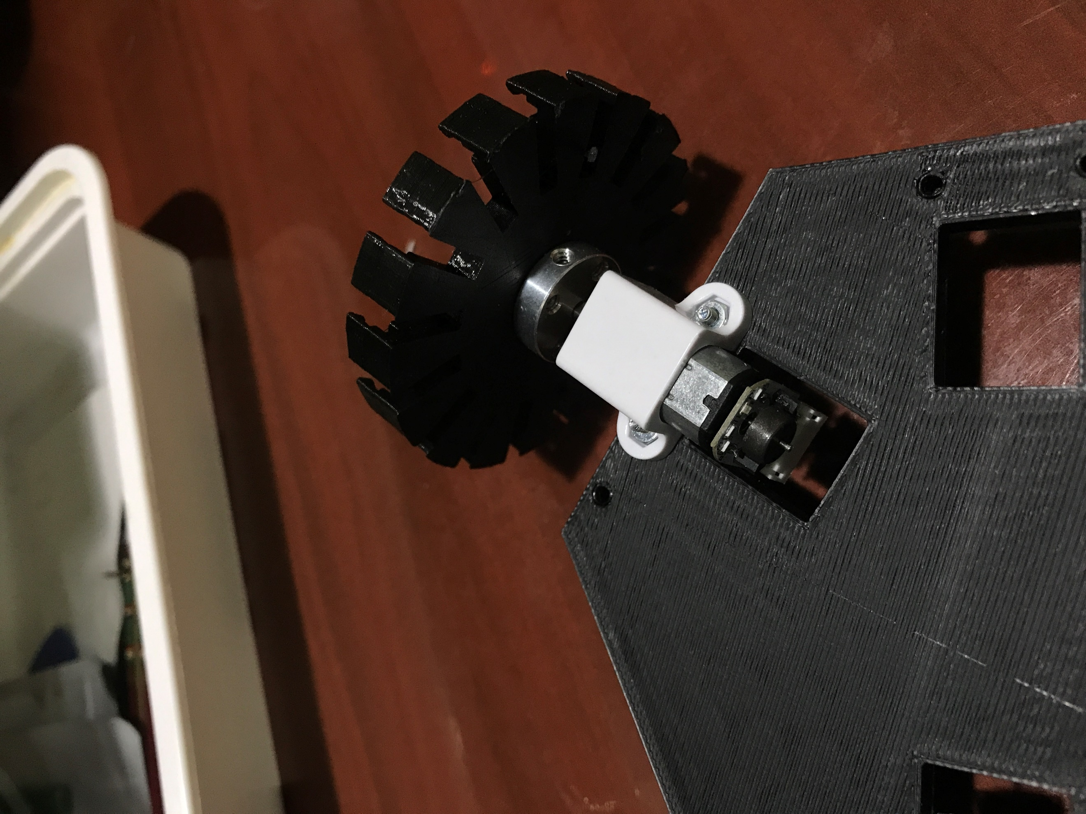 Screw and Nut(provided with brackets)

Motor(with attached encoder. Note: The wire connection is going through the hole in the chassis)

Hub

Motor Bracket

Wheel(Missing miniwheels)

* Attach 3" spacers to chassis

* Place camera in camera enclosure and screw on front. (Holes may need to be cleaned out with a drill)

* Plug AMD into Raspberry Pi

* Screw in 1/2 inch spacers in between AMD and Pi

* Screw in 1 inch spacers to remaining 2 holes on pi

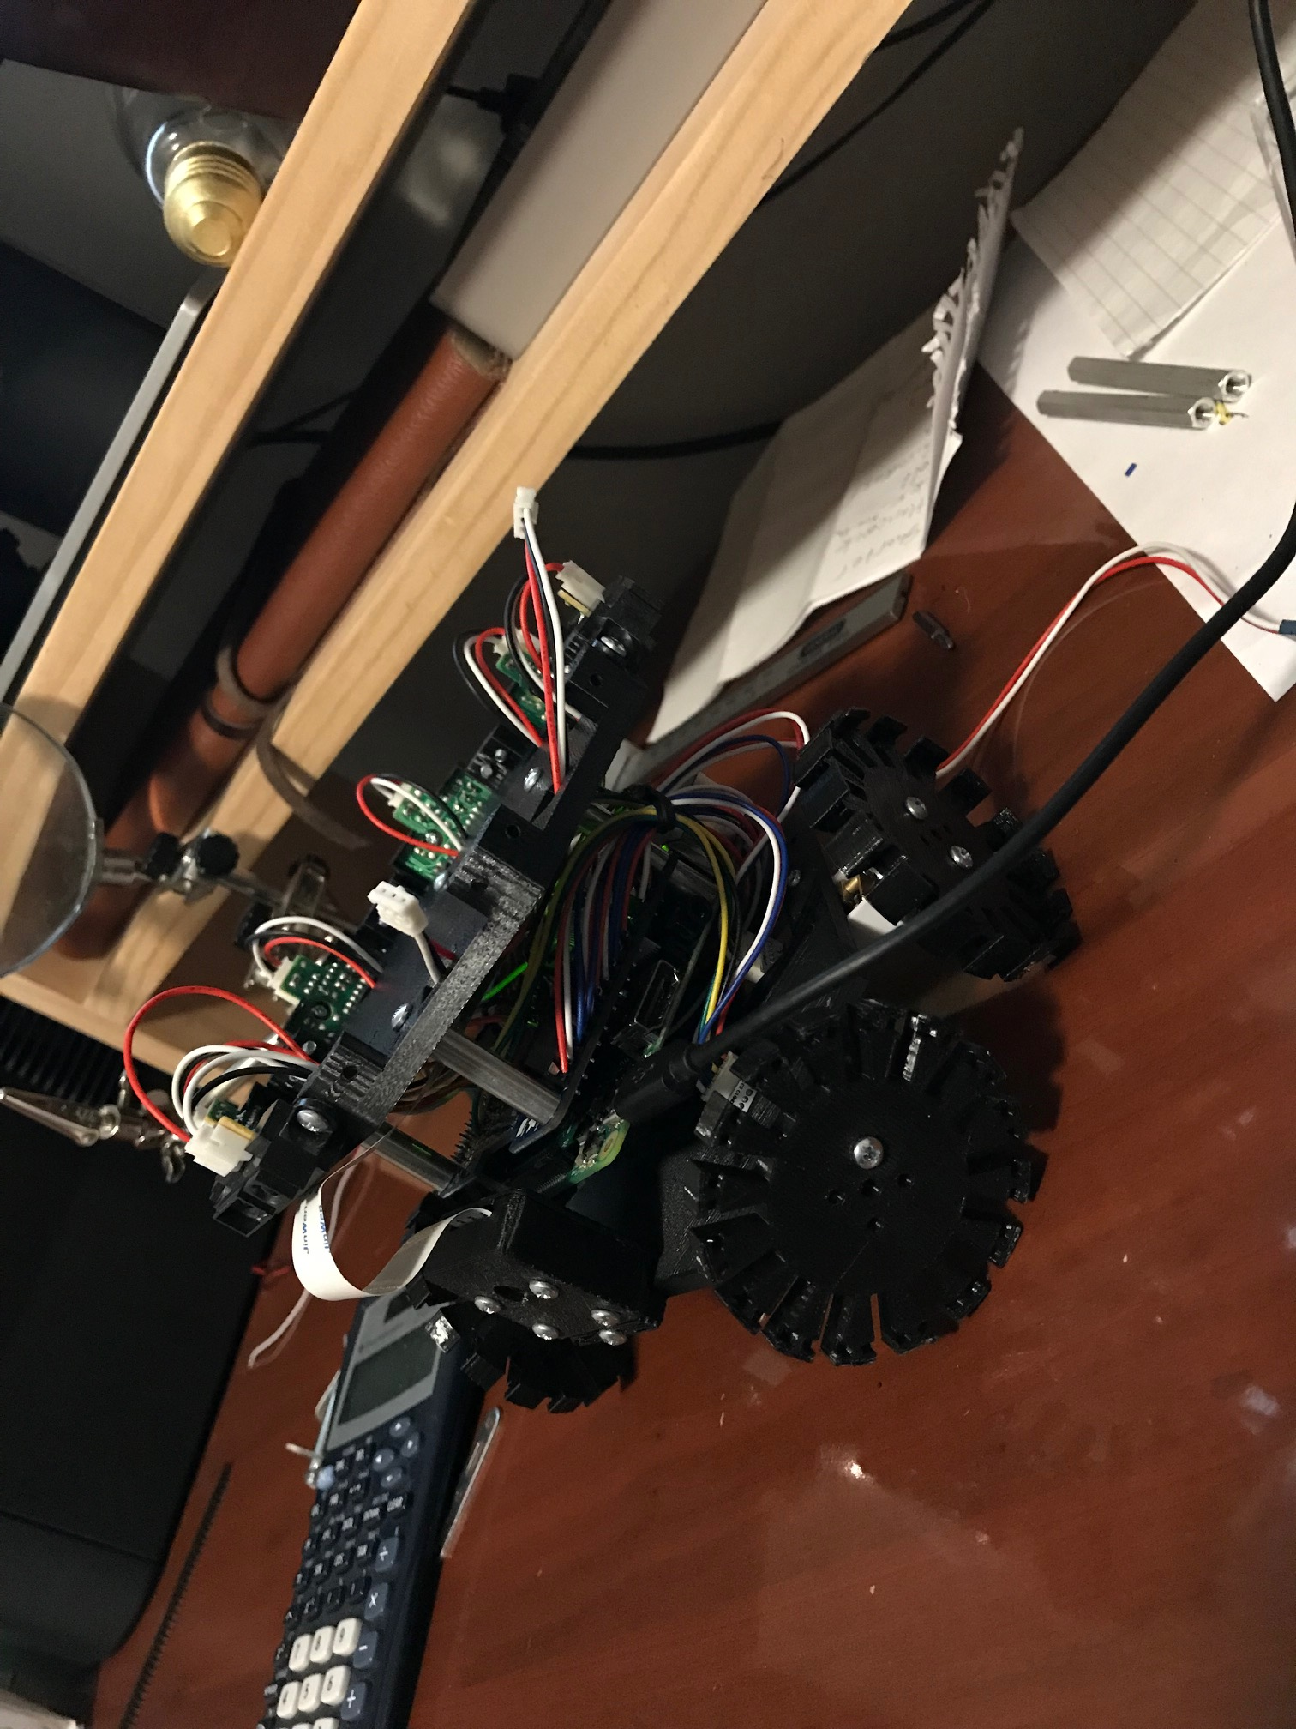

Sharp Sensor

Sensorholder

1” Spacer

AMD

Camera Enclosure(camera inside)

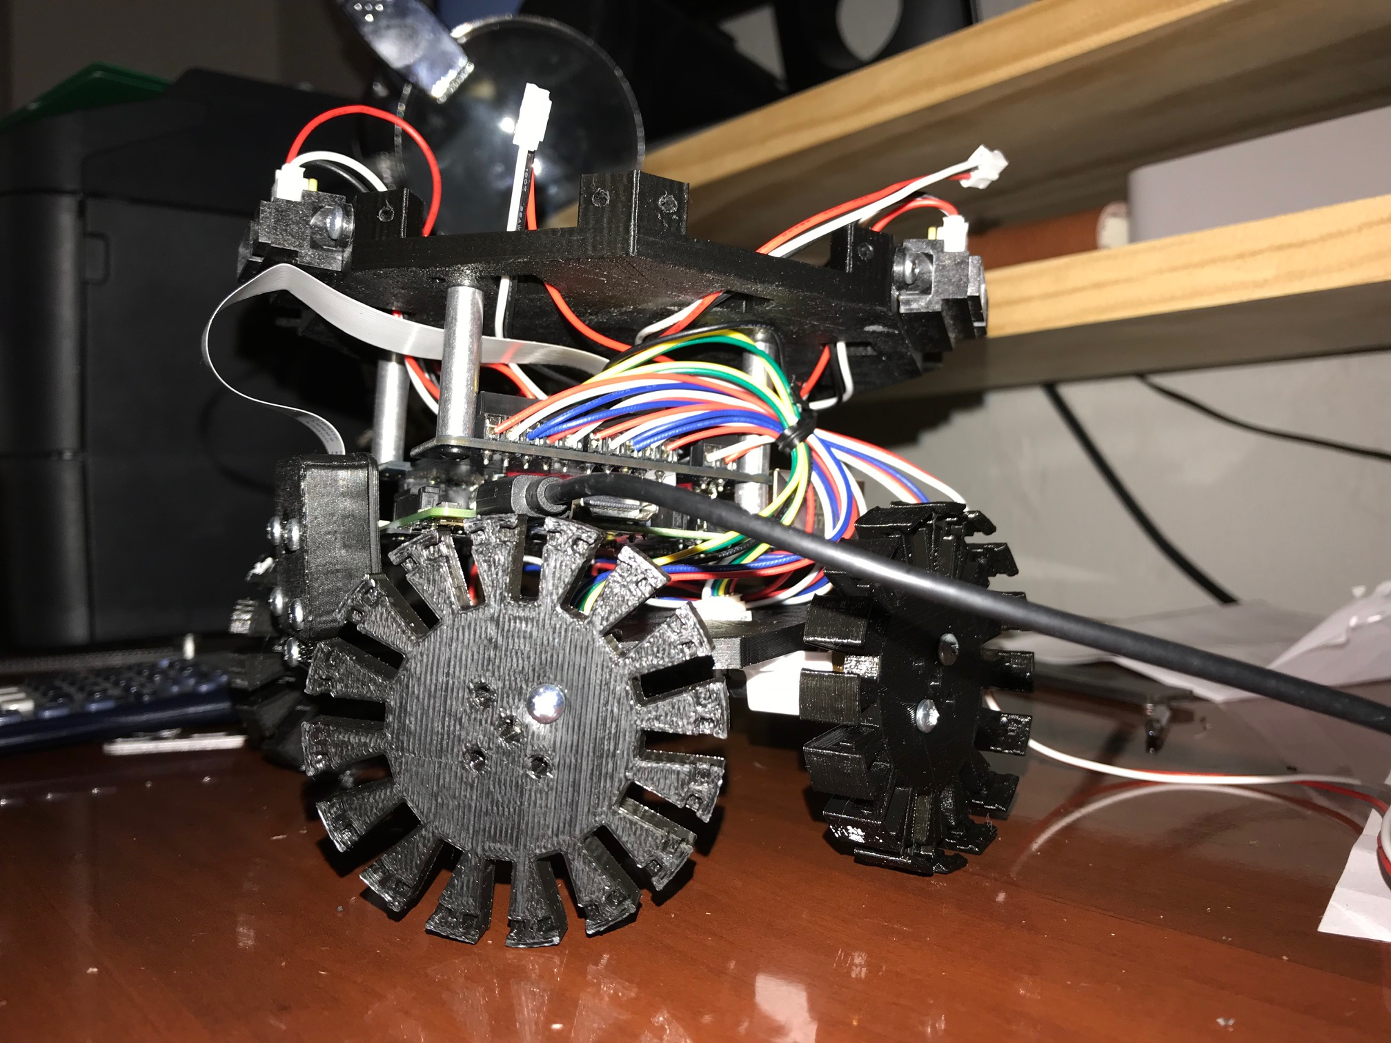

* Screw in to sensor holder

* Pass sensors through holes in sensor holder

* Screw in sensors to sensor holder

* Screw camera into chassis

* Screw in 3 inch spacers to chassis and sensor holder

* Celebrate because you have completed your mission to build a robotito

* Lament because now you have to do the programming(Just kidding it's really not that bad)

SOFTWARE

* Download Raspbian Linux (Stretch)

download here https://www.raspberrypi.org/downloads/raspbian/

(Download via torrent, if you value your time)

The .iso will need to go on a SD card of at least 8GB.

* To login in remotely, enable SSH before you boot. Create a file called ssh(no file format!!) in the boot partition (the only partition that's normally visible to Windows and Mac computers). The ssh file does not have to contain anything, it's presence tells Raspbian you want SSH enabled and the file will be deleted after that's done.

User name: pi

Password: raspberry

(Change pw ASAP)

* Update

sudo apt-get update

* Get python-dev

sudo apt-get install python-dev python-pip

pip install upgrade distribute

pip install upgrade rpi.gpio

* Install Adafruit Motor-HAT-Python Library

https://github.com/adafruit/Adafruit-Motor-HAT-Python-Library

* Install Adafruit MCP3008 Library

sudo apt-get update

sudo apt-get install build-essential python-dev python-smbus git

cd ~

git clone https://github.com/adafruit/Adafruit_Python_MCP3008.git

cd Adafruit_Python_MCP3008

sudo python setup.py install

sudo apt-get update

sudo apt-get install build-essential python-dev python-smbus python-pip

sudo pip install adafruit-mcp3008

* Turn on camera, spi and i2c

sudo raspi-config (in interfacing options, and turn each one on)

(using lsmod, you should see spi_bcm2835, i2c_bcm2835)

* Install Raspbian on Pi

CRAZYFLIE

The purpose of the testing of the Crazyflie was to establish its viability as a drone for use in the lab. If the tutorial is followed the user will be able to use the Crazyflie demo files, which includes hovering, control in ROS, and waypoint navigation.

The battery life of the Crazyflie

* Install dependencies

Ros (lunar)

Crazyflie-ROS

cfclient

git clone https://github.com/bitcraze/Crazyflie-client-python

git clone https://github.com/whoenig/Crazyflie_ros.git

dependencies for controllers (you will need Xbox and Wi controllers)

follow the setup instructions here (beginning on pg. 4)

http://act.usc.edu/publications/Hoenig_Springer_ROS2017.pdf

* Every time a new instance of catkin workspace is made, make sure you type

source/devel/setup.bash